**VOICE CONTROLLED LINE FOLLOWING BOT**

**Project Review Report-1**

Submitted towards the course

**15Z610 EMBEDDED SYSTEMS LAB**

By

Suklesh S Rao(16z355)

1. Akash (17z315)

Katta Midhunesh (17z325)



**Department of Computer Science and Engineering,**

**PSG College of Technology,**

**Coimbatore.**

**Introduction:**

This project is a line following bot that runs on voice commands that are interfaced through Bluetooth from application to bot. We use this to direct the bot to certain destination that we want it to go through an application. We can have several destination such as A, B and C and using the voice commands the bot can navigate to the right destination. The application has various functions such as manual control, like basic buttons such as forward, backward, left and right. It also has a Bluetooth mode where in we use the voice commands that are spoken to move the bot

**Problem Statement:**

In hostile places where humans are at risk at any moment, such as places of highly militarized places, like borders or hostile places of terrorists it not advised to let humans sacrifice themselves for potential danger.

In cases like this it would be better to send in a bot which would help to minimize the chances of human fatality. It could be used in investigation missions wherein using a Bluetooth to communicate will make it easier to use the bot.

Therefore we use this project to command the bot to move to places we desire it to go. We can have multiple destinations and using the voice commands to differentiate the places we can instruct the bot to go to different destinations.

**Components Required:**

**Hardware:**

1. 2 Wheels (2-4)
2. Chassis
3. Ardunio Uno
4. 293 Motor Control Shield - It is a dual-channel H-Bridge motor driver capable of driving a pair of DC motors or single stepper motor. As the shield comes with two L293D motor driver chipsets, that means it can individually drive up to four DC motors making it ideal for building four-wheel robot platforms.
5. Batteries (2)
6. Arduino Cable
7. IR Sensors (2) - Used for finding obstacles.
8. Jumper Wires
9. Breadboard

**Software:**

Ardunio IDE

**Schematic Diagram**

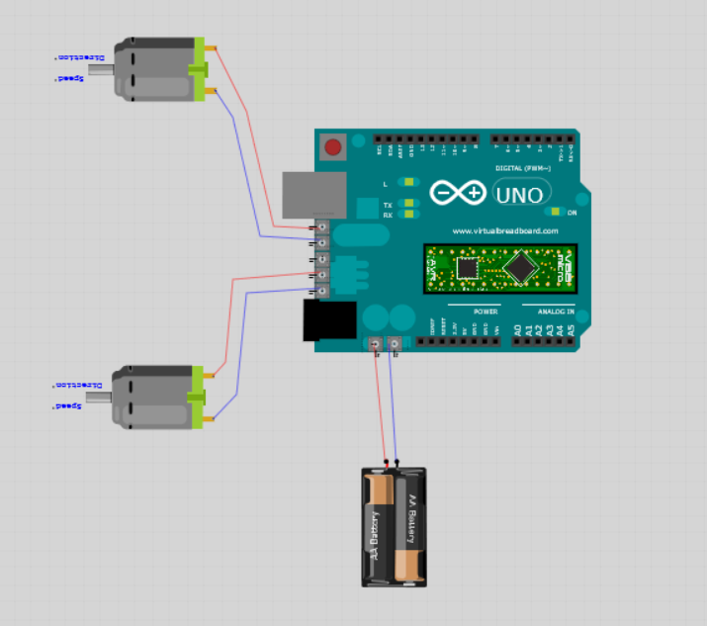

Ardunio Uno

Battery

Motor Driver Shield

Motor 2

Motor 1

**Code:**

#include <AFMotor.h> //Ada fruit motor shield

AF_DCMotor motor(1,MOTOR12_8KHZ); //Motor Initialization

AF_DCMotor motor1(2,MOTOR12_8KHZ);

const int Ps=A0; //Proximity sensor initialization

int input = 0; // Variable declaration

void setup()

{

motor.setSpeed(200); //Setting motor speed to 200 RPM

motor1.setSpeed(200); //Setting second motor speed to 200 RPM

Serial.begin(9600);

}

void loop() {

if(digitalRead(Ps)==HIGH) //Check the sensor output

{

digitalWrite(13, HIGH);

Serial.println("no obstacles"); // Set the LED off, no obstacle is present so the bot can move forward

motor1.run(FORWARD); //Bot moves in forward direction

motor.run(FORWARD);

}

else

{

digitalWrite(13, LOW);

motor.run(RELEASE); //Making the bot stop

motor1.run(RELEASE);

Serial.println("obstacles Ahead"); // Set the LED to switch on

}

input = analogRead(Ps);

Serial.println(input);

delay(1000);

}

**Challenges Faced:**

* High voltage batteries can’t be used for running the motor by interfacing with Arduino software using motor interface.
* Sensors will not work properly some times they will not detect the tape which was used for line following.
* One motor blew up when we supplied it with 12V direct charge. We have rectified that mistake.

**Contribution of team members:**

**Suklesh Rao:** Contributed Bluetooth Module and overall idea of the project, along with a spare motor and help with interfacing the Bluetooth Module and fixing the module on the bot. Helped with code of the bot.

**Akash:** Contributed in the construction of the bot and helped in interfacing of motor with Arduino ide and did the sensor interfacing and line following work. And did the coding for both motor interface and sensor interface.

**Midhunesh:**

Helped in making report and construction of the Bot. And helped in doing the interface for motor and Arduino. And helped in building the code for sensor and motor interface.

All the team members are involved in developing the app.

**References:**

How to make a line a following bot using Arduino with programming

<https://youtu.be/QAkmBtT7aLc>